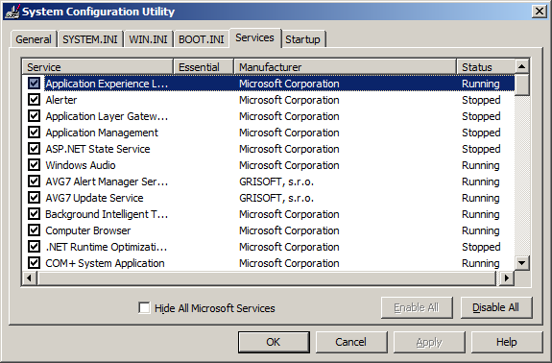
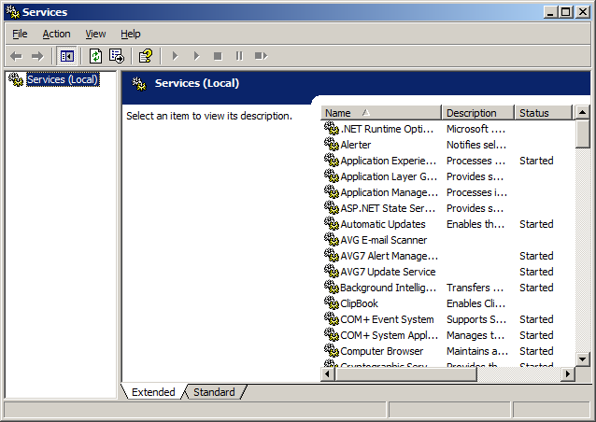

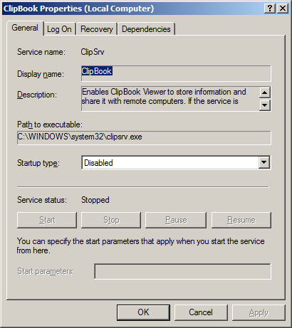
Summary
This was done on my Windows Server 2003 Workstation conversion, and I pretty much already killed all of the unimportant services already. ClipBook was always disabled on this machine due to it being an already useless service. In Vista, it's gone for good. One thing I am aware of is that msconfig is the absolute wrong way to disable or stop services. It apparently modifies the registry keys directly and doesn't call the stop/disable system calls, which can leave the system in a non-bootable or otherwise broken state. Another thing that I noticed is that Windows Server 2003 has a few different names for some services. “Wireless Zero Configuration” is now “Wireless Configuration” for example.

